Assignment submission cover sheet

Student ID:
Cse25-226

Student names:
Martin Botlhe Tshekiso

Student email:
Cse25-226@thuto.bac.ac.bw

Cohort:
2025

Assignment title:
SCIS WMD_2026 AO1

Date of submission:
20 May 2026

Programme of study:
Computer Systems Engineering

Year of study:
Year 1

Intellectual property statement

By checking the box below, i certify that this assignment is my own work and is free from plagiarism. I understand that the assignment may be checked for plagiarism by electronic or other means and may be transferred and stored in a database for the purposes of data-matching to help detect plagiarism. The assignment has not previously been submitted for assessment in any other unit or to any other institution. I have read and understood the Botswana Accountancy College plagiarism guidelines policy.

Agree: YES Signature: M.Tshekiso
Date: 19 March 2026
[School]
[Course title]

DTEF Botswana Website
Website Planning and Documentation
Project Overview
The Department of Tertiary Education Financing (DTEF) Website is a government e service portal designed to revolutionize tertiary education sponsorship in Botswana. This comprehensive planning document outlines the website's strategic vision, technical implementation, and operational roadmap.

Project Goals
Processing Time: Reduced from 3-4 months to 14 days average – a 90% improvement
Application Volume: Increased from manual capacity to support thousands of concurrent applications
User Satisfaction: Target of 95% satisfaction rate among applicants
Accessibility: 100% of students can access the platform from any location with internet
System Uptime: Target of 99.9% uptime ensuring the platform is always available
Support Response Time: Email support responds within 24 hours; live chat available during business hours

GOALS ON STUDENTS
Increased Access: Students from all regions of Botswana can now apply for sponsorship
Faster Decisions: Students receive sponsorship decisions in time to meet enrollment deadlines
Reduced Stress: Transparent tracking and responsive support reduce anxiety about the application process
Better Information: Comprehensive resources provide answers to questions without waiting
Equal Opportunity: Geographic location no longer determines access to sponsorship

GOALS ON DTEF
Improved Efficiency: Staff productivity increased through automation and digital workflows
Cost Reduction: Operational costs reduced through elimination of paper-based processes
Better Data: Centralized digital records enable better analysis and reporting
Enhanced Accountability: Transparent tracking creates audit trail of all decisions
Scalability: System can handle growth without proportional increase in staffing

GOALS ON BATSWANA
Educational Access: More students can access tertiary education
Equity: Sponsorship opportunities distributed equitably across all regions
Economic Development: More educated workforce supports economic growth
Digital Leadership: DTEF demonstrates government commitment to digital transformation
National Development: Supports achievement of national education and development goals

Website Specifications
Website Purpose & Objectives
Primary Purpose:
Provide a centralized digital platform for tertiary education sponsorship applications and management

Secondary Purposes:
• Educate students about sponsorship programs
• Provide transparent application tracking
• Offer comprehensive support resources
• Enable efficient staff administration
• Collect and analyze application data

Target Audience
Student Applicants
• Age: 16-35 years old
• Education: Secondary school graduates, tertiary students
• Location: All regions of Botswana (urban and rural)
• Technical Skill: Moderate to high
• Internet Access: Moderate (improving)

Rural/Underserved Students
• Age: 18-30 years old
• Education: Secondary school graduates
• Location: Rural areas, remote regions
• Technical Skill: Low to moderate
• Internet Access: Limited but improving

Parents/Guardians
• Age: 40-65 years old
• Education: Varies
• Location: All regions
• Technical Skill: Low to moderate
• Internet Access: Moderate

DTEF Staff
• Age: 25-55 years old
• Education: Tertiary
• Location: Gaborone and regional offices
• Technical Skill: Moderate to high
• Internet Access: Full

Type of website
Core Features:
• Online application system
• Real-time application tracking
• Comprehensive information resources
• FAQ and support section
• Contact and feedback system
• Secure login portal
• Document upload and management
• Email notification system

Pages:
• Home page
• About DTEF
• Apply for Sponsorship
• Application Dashboard
• Requirements & Eligibility
• Support & FAQ
• Contact & Feedback
• Login Portal

Technical Features:
• Responsive design (mobile, tablet, desktop)
• Cross-browser compatibility
• Performance optimization
• Security implementation
• Form validation
• Error handling
• Analytics tracking

Information Design and Taxonomy
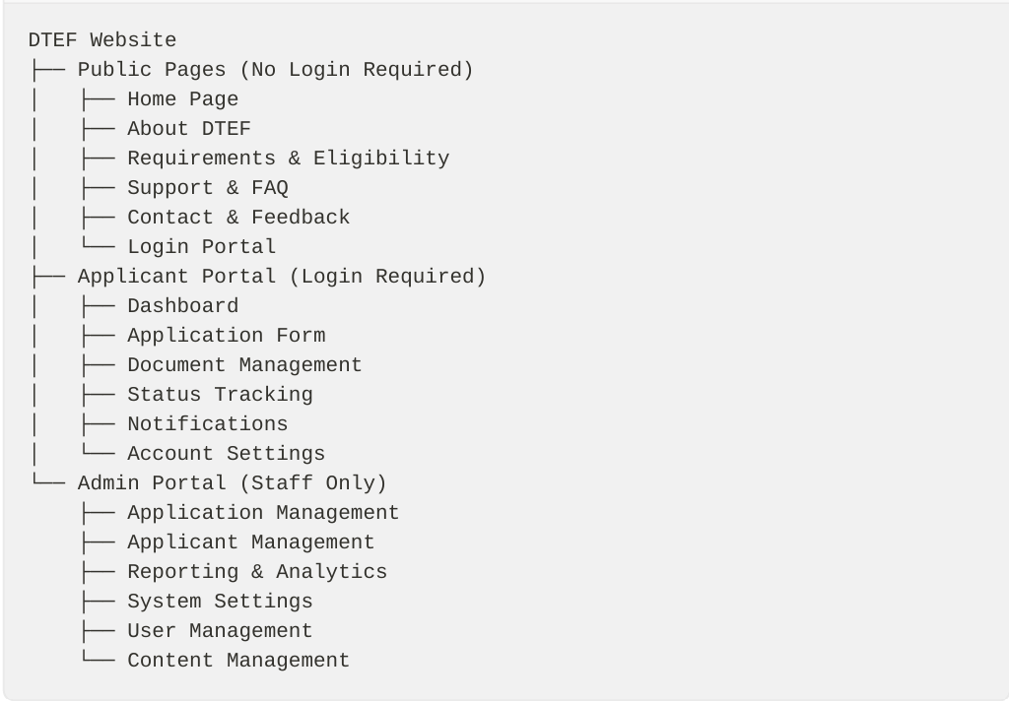
Key Features & Functionality

Online Application System
Description: Multi-step form for submitting sponsorship applications
Functionality:
• Personal information collection
• Educational background details
• Financial information
• Document upload (5 documents max, 5MB each)
• Agreement acceptance
• Form validation and error checking
• Auto-save functionality
• Progress tracking
IMPORTANCE: Students can apply from anywhere, anytime
BUSINESS IMPORTANCE: Automated data collection, reduced manual entry

Application Dashboard
Description: Real-time tracking of application status
Functionality:
• Application status display (Submitted, Under Review, Approved, Rejected)
• Timeline view of application progress
• Document management interface
• Notification history
• Quick statistics (total applications, approved, pending)
• Download decision letters
IMPORTANCE: Transparency and peace of mind
BUSINESS ESSENTIAL: Reduced support inquiries, improved satisfaction

Requirements & Eligibility
Description: Clear communication of sponsorship requirements
Functionality:
• Eligibility criteria listing
• Required documents checklist
• Program-specific requirements
• Application deadlines
• FAQ section
• Downloadable guides
IMPORTANCE: Clear understanding of requirements before applying
BUSINESS ESSENTIAL: Reduced invalid applications, improved quality

Support & FAQ
Description: Comprehensive self-service support
Functionality:
• Searchable FAQ database
• Categorized questions
• Collapsible accordion format
• Related articles
• Contact support option
• Feedback mechanism
IMPORTANCE: 24/7 support access, quick answers
BUSINESS IMPORTANCE: Reduced support tickets, improved efficiency

Secure Login System
Description: Dual-portal authentication system
Functionality:
• Email/username login
• Password reset functionality
• Session management
• Account security features
• Role-based access (applicant and admin)
• Activity logging
IMPORTANCE: Secure access to personal information
BUSINESS ESSENTIAL: Data security, audit trail
Notification System
Description: Automated email notifications
Functionality:
•Application confirmation
•Status updates
•Deadline reminders
•Decision notifications
•Support responses
•System announcements
BENEFIT: Stay informed without checking website
BUSINESS BENEFIT: Improved communication, reduced inquiries

Site Map
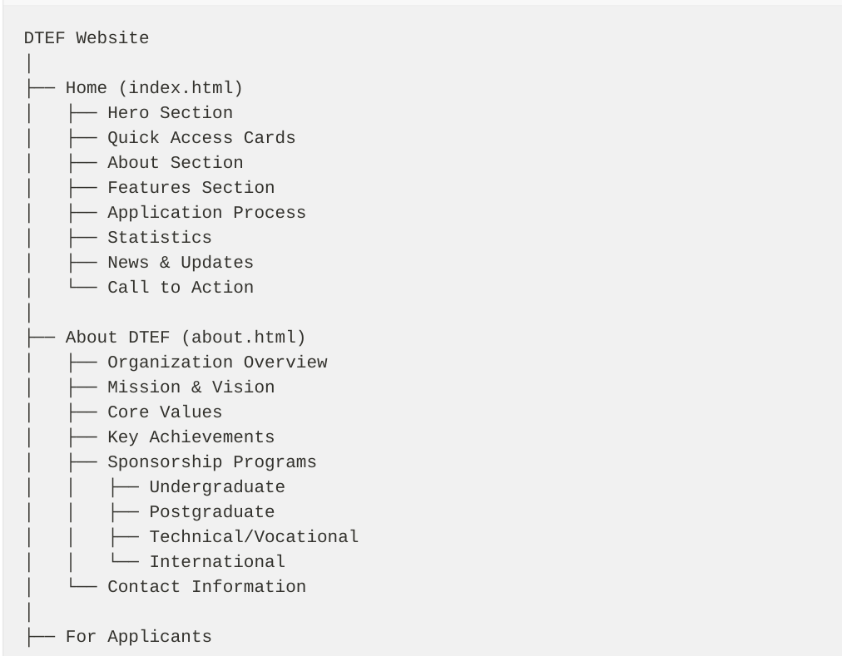
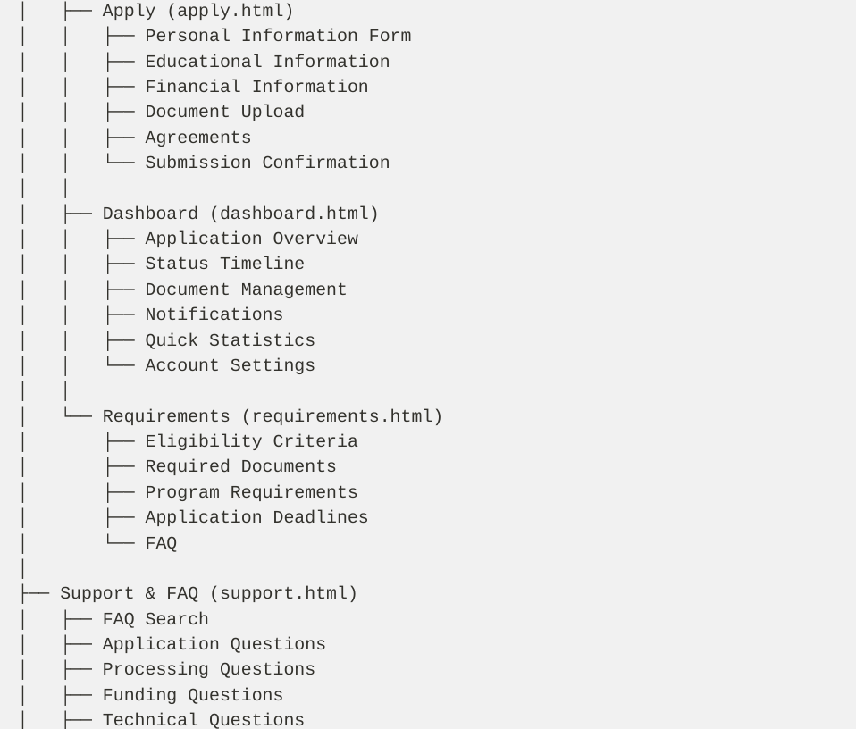
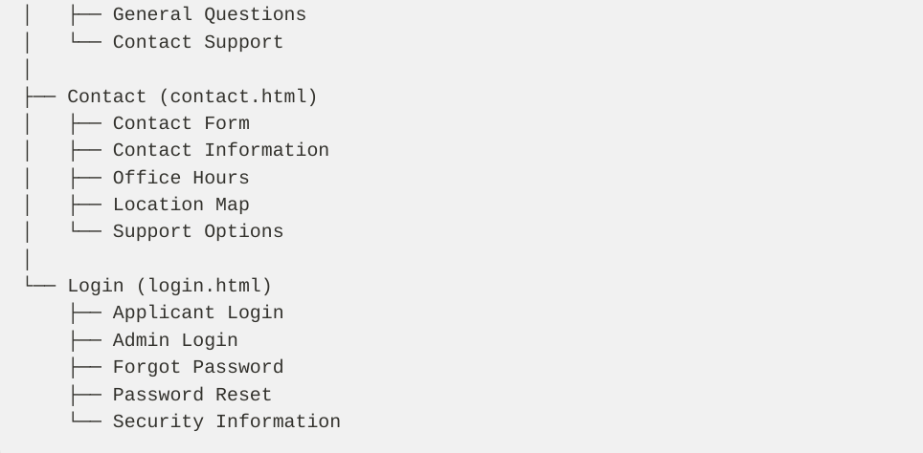
Navigation Structure

Primary Navigation (Header):
• Home
• About DTEF
• For Applicants (Dropdown)
• Apply for Sponsorship
• Track Application
• Requirements
• Support & FAQ
• Contact
• Login

Secondary Navigation (Footer):
• About DTEF
• Apply for Sponsorship
• Requirements
• Support & FAQ
• Contact
• Privacy Policy
• Terms of Service
• Accessibility Statement

User Journey Maps
New Applicant Journey
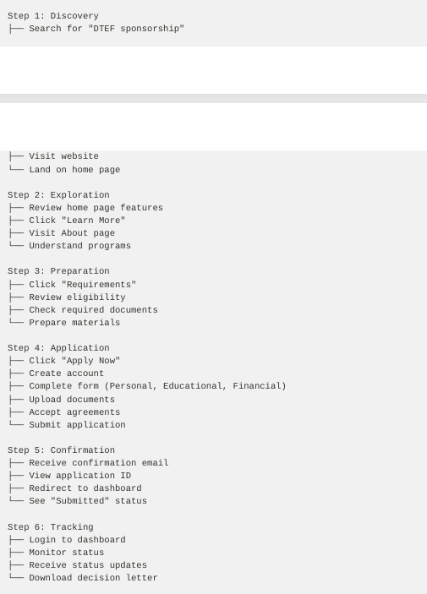
Support Seeker
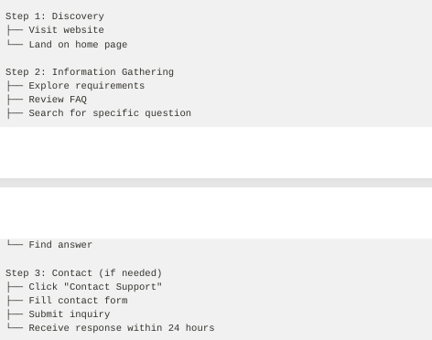

Returning Applicant
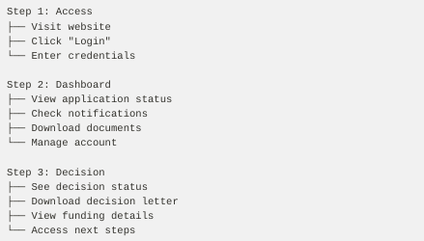


The website was built using basic tools. These are the technologies and software used:
Languages
- HTML for structure
- CSS for design
Software tools
- Visual Studio Code for coding
- Canva for images
- GitHub for hosting and version control
Browser Developer Tools for testing

Wireframes and Layout Specifications

Purpose
Wireframes provide a visual blueprint of the website layout, showing the structure, hierarchy, and placement of elements on each page. They serve as a guide for development and ensure consistency across all pages.

Wireframe Explanations
- Boxes with labels: Represent content areas and components
- [PLACEHOLDER]: Indicates image or media areas
- Text descriptions: Show content type and purpose
- Dimensions: Shown in percentages and relative sizes
- Responsive notes: Indicate how layout changes on mobile

They should also be:
- All pages follow the same structural template
- Most important content is most prominent
- Adequate spacing for readability
- Layouts adapt to different screen sizes
- Clear navigation and logical flow

Common Components

Header/Navigation Component
┌─────────────────────────────────────────────────────────────────┐
│ [LOGO] DTEF Botswana │ Home About For Applicants Support │
│ │ Contact Login │
└─────────────────────────────────────────────────────────────────┘

Mobile Phone version
┌──────────────────────────────────────┐
│ [LOGO] DTEF │ ☰ Menu │ Login │
└──────────────────────────────────────┘

Footer
┌─────────────────────────────────────────────────────────────────┐
│ About DTEF │ Apply Now │ Requirements │ Support │ Contact │
├─────────────────────────────────────────────────────────────────┤
│ © 2026 Department of Tertiary Education Financing │
│ Privacy Policy │ Terms of Service │ Accessibility Statement │
└─────────────────────────────────────────────────────────────────┘

Page Wireframes

Page 1: Home Page (index.html)

Full Page Layout
┌─────────────────────────────────────────────────────────────────┐
│ NAVIGATION BAR │
├─────────────────────────────────────────────────────────────────┤
│ │
│ HERO SECTION │
│ (Full width, gradient background) │
│ │
│ "Department of Tertiary Education Financing" │
│ "Empowering Botswana's Students Through Quality Education" │
│ │
│ [Apply Now Button] [Learn More Button] │
│ │
├─────────────────────────────────────────────────────────────────┤
│ QUICK ACCESS SECTION │
│ ┌──────────────┐ ┌──────────────┐ ┌──────────────┐ │
│ │ Apply Online │ │ Track Status │ │ Requirements │ │
│ │ [Icon] │ │ [Icon] │ │ [Icon] │ │
│ │ Description │ │ Description │ │ Description │ │
│ │ [Button] │ │ [Button] │ │ [Button] │ │
│ └──────────────┘ └──────────────┘ └──────────────┘ │
│ ┌──────────────┐ │
│ │ Get Support │ │
│ │ [Icon] │ │
│ │ Description │ │
│ │ [Button] │ │
│ └──────────────┘ │
├─────────────────────────────────────────────────────────────────┤
│ ABOUT SECTION │
│ ┌──────────────────┐ ┌──────────────────┐ │
│ │ Text Content: │ │ [PLACEHOLDER │ │
│ │ - About DTEF │ │ IMAGE] │ │
│ │ - Mission │ │ │ │
│ │ - Achievements │ │ │ │
│ │ [Learn More] │ │ │ │
│ └──────────────────┘ └──────────────────┘ │
├─────────────────────────────────────────────────────────────────┤
│ FEATURES SECTION │
│ ┌──────────────┐ ┌──────────────┐ ┌──────────────┐ │
│ │ Fast │ │ Secure & │ │ Accessible │ │
│ │ Processing │ │ Confidential │ │ Anywhere │ │
│ │ [Icon] │ │ [Icon] │ │ [Icon] │ │
│ └──────────────┘ └──────────────┘ └──────────────┘ │
│ ┌──────────────┐ ┌──────────────┐ ┌──────────────┐ │
│ │ Real-time │ │ 24/7 Support │ │ National │ │
│ │ Tracking │ │ │ │ Coverage │ │
│ │ [Icon] │ │ [Icon] │ │ [Icon] │ │
│ └──────────────┘ └──────────────┘ └──────────────┘ │
├─────────────────────────────────────────────────────────────────┤
│ APPLICATION PROCESS SECTION │
│ Step 1: Register Step 2: Complete Step 3: Submit │
│ ┌────────────┐ ┌────────────┐ ┌────────────┐ │
│ │ Create │ → │ Fill Form │ → │ Upload │ │
│ │ Account │ │ & Details │ │ Documents │ │
│ └────────────┘ └────────────┘ └────────────┘ │
│ │
│ Step 4: Track & Receive │
│ ┌────────────┐ │
│ │ Monitor │ │
│ │ Status │ │
│ └────────────┘ │
├─────────────────────────────────────────────────────────────────┤
│ STATISTICS SECTION │
│ ┌──────────────┐ ┌──────────────┐ ┌──────────────┐ │
│ │ 5000+ │ │ 95% │ │ 14 Days │ │
│ │ Applications │ │ Approval │ │ Processing │ │
│ │ Processed │ │ Rate │ │ Time │ │
│ └──────────────┘ └──────────────┘ └──────────────┘ │
│ ┌──────────────┐ │
│ │ 100% │ │
│ │ Geographic │ │
│ │ Coverage │ │
│ └──────────────┘ │
├─────────────────────────────────────────────────────────────────┤
│ NEWS & UPDATES SECTION │
│ ┌──────────────┐ ┌──────────────┐ ┌──────────────┐ │
│ │ [IMAGE] │ │ [IMAGE] │ │ [IMAGE] │ │
│ │ News Title 1 │ │ News Title 2 │ │ News Title 3 │ │
│ │ Date: ... │ │ Date: ... │ │ Date: ... │ │
│ │ [Read More] │ │ [Read More] │ │ [Read More] │ │
│ └──────────────┘ └──────────────┘ └──────────────┘ │
├─────────────────────────────────────────────────────────────────┤
│ CALL TO ACTION SECTION │
│ Ready to Apply for Sponsorship? │
│ [Apply Now Button] │
├─────────────────────────────────────────────────────────────────┤
│ FOOTER │
└─────────────────────────────────────────────────────────────────┘

Desktop Layout
- Hero section: Full width with centered content
- Quick access: 4 cards in a row
- About section: 2-column layout (text left, image right)
- Features: 3 columns × 2 rows

Tablet Layout
- Hero section: Full width, adjusted padding
- Quick access: 2 cards per row
- About section: Stacked (text top, image bottom)

Mobile Layout
- Hero section: Full width, reduced padding
- Quick access: 1 card per row, stacked
- About section: Stacked vertically
- Features: 1 column, stacked

Page 2: About DTEF (about.html)

Full Page Layout
┌─────────────────────────────────────────────────────────────────┐
│ NAVIGATION BAR │
├─────────────────────────────────────────────────────────────────┤
│ PAGE HEADER │
│ About DTEF │
│ Department of Tertiary Education Financing │
├─────────────────────────────────────────────────────────────────┤
│ ORGANIZATION OVERVIEW SECTION │
│ ┌──────────────────────────────────────────────────────────┐ │
│ │ DTEF is a government institution dedicated to providing │ │
│ │ financial support to deserving Botswana citizens... │ │
│ │ │ │
│ │ Our mission is to make quality education accessible... │ │
│ └──────────────────────────────────────────────────────────┘ │
├─────────────────────────────────────────────────────────────────┤
│ MISSION & VISION SECTION │
│ ┌──────────────────────┐ ┌──────────────────────┐ │
│ │ MISSION │ │ VISION │ │
│ │ [Icon] │ │ [Icon] │ │
│ │ To provide financial │ │ A Botswana where all │ │
│ │ support to deserving │ │ qualified students │ │
│ │ students... │ │ have access to... │ │
│ └──────────────────────┘ └──────────────────────┘ │
├─────────────────────────────────────────────────────────────────┤
│ CORE VALUES SECTION │
│ ┌──────────────┐ ┌──────────────┐ ┌──────────────┐ │
│ │ EQUITY │ │ EXCELLENCE │ │ INTEGRITY │ │
│ │ [Icon] │ │ [Icon] │ │ [Icon] │ │
│ │ Description │ │ Description │ │ Description │ │
│ └──────────────┘ └──────────────┘ └──────────────┘ │
│ ┌──────────────┐ ┌──────────────┐ │
│ │ TRANSPARENCY │ │ EFFICIENCY │ │
│ │ [Icon] │ │ [Icon] │ │
│ │ Description │ │ Description │ │
│ └──────────────┘ └──────────────┘ │
├─────────────────────────────────────────────────────────────────┤
│ KEY ACHIEVEMENTS SECTION │
│ Timeline View: │
│ 2015: DTEF Established │
│ 2018: Regional Offices Opened │
│ 2022: Digital Platform Launched │
│ 2026: 50,000+ Students Supported │
├─────────────────────────────────────────────────────────────────┤
│ SPONSORSHIP PROGRAMS SECTION │
│ ┌──────────────────┐ ┌──────────────────┐ │
│ │ UNDERGRADUATE │ │ POSTGRADUATE │ │
│ │ [Icon] │ │ [Icon] │ │
│ │ Description... │ │ Description... │ │
│ │ [Learn More] │ │ [Learn More] │ │
│ └──────────────────┘ └──────────────────┘ │
│ ┌──────────────────┐ ┌──────────────────┐ │
│ │ TECHNICAL/ │ │ INTERNATIONAL │ │
│ │ VOCATIONAL │ │ PROGRAMS │ │
│ │ [Icon] │ │ [Icon] │ │
│ │ Description... │ │ Description... │ │
│ │ [Learn More] │ │ [Learn More] │ │
│ └──────────────────┘ └──────────────────┘ │
├─────────────────────────────────────────────────────────────────┤
│ CALL TO ACTION SECTION │
│ Ready to Apply for Sponsorship? │
│ [Apply Now Button] │
├─────────────────────────────────────────────────────────────────┤
│ FOOTER │
└─────────────────────────────────────────────────────────────────┘

Key Layout Features
- Page header with title and breadcrumb
- Overview section with introductory text
- Mission and vision in side-by-side cards
- Core values in a grid (2-3 columns)
- Timeline for achievements
- Program cards in a grid
- Call-to-action section
- Footer with links

Page 3: Apply for Sponsorship (apply.html)

Full Page Layout
┌─────────────────────────────────────────────────────────────────┐
│ NAVIGATION BAR │
├─────────────────────────────────────────────────────────────────┤
│ PAGE HEADER │
│ Apply for Sponsorship │
│ Complete the form below to apply for sponsorship │
├─────────────────────────────────────────────────────────────────┤
│ PROGRESS INDICATOR │
│ Step 1: Personal ▶ Step 2: Education ▶ Step 3: Financial ▶ │
│ Step 4: Documents ▶ Step 5: Agreements ▶ Submit │
│ ████░░░░░░░░░░░░░░░░░░░░░░░░░░░░░░░░░░░░░░░░░ 20% │
├─────────────────────────────────────────────────────────────────┤
│ FORM SECTION 1: PERSONAL INFORMATION │
│ ┌─────────────────────────────────────────────────────────┐ │
│ │ Full Name * │ │
│ │ ┌─────────────────────────────────────────────────────┐ │ │
│ │ │ [Text Input] │ │ │
│ │ └─────────────────────────────────────────────────────┘ │ │
│ │ │ │
│ │ Email Address * │ │
│ │ ┌─────────────────────────────────────────────────────┐ │ │
│ │ │ [Email Input] │ │ │
│ │ └─────────────────────────────────────────────────────┘ │ │
│ │ │ │
│ │ Phone Number * │ │
│ │ ┌─────────────────────────────────────────────────────┐ │ │
│ │ │ [Phone Input] │ │ │
│ │ └─────────────────────────────────────────────────────┘ │ │
│ │ │ │
│ │ National ID / Passport Number * │ │
│ │ ┌─────────────────────────────────────────────────────┐ │ │
│ │ │ [Text Input] │ │ │
│ │ └─────────────────────────────────────────────────────┘ │ │
│ │ │ │
│ │ Date of Birth * │ │
│ │ ┌─────────────────────────────────────────────────────┐ │ │
│ │ │ [Date Input] │ │ │
│ │ └─────────────────────────────────────────────────────┘ │ │
│ └─────────────────────────────────────────────────────────┘ │
├─────────────────────────────────────────────────────────────────┤
│ FORM SECTION 2: EDUCATIONAL INFORMATION │
│ ┌─────────────────────────────────────────────────────────┐ │
│ │ Institution Name * │ │
│ │ ┌─────────────────────────────────────────────────────┐ │ │
│ │ │ [Text Input / Dropdown] │ │ │
│ │ └─────────────────────────────────────────────────────┘ │ │
│ │ │ │
│ │ Program / Course * │ │
│ │ ┌─────────────────────────────────────────────────────┐ │ │
│ │ │ [Text Input] │ │ │
│ │ └─────────────────────────────────────────────────────┘ │ │
│ │ │ │
│ │ Level of Study * │ │
│ │ ┌─────────────────────────────────────────────────────┐ │ │
│ │ │ [Dropdown: Undergraduate / Postgraduate / Other] │ │ │
│ │ └─────────────────────────────────────────────────────┘ │ │
│ │ │ │
│ │ Program Start Date * │ │
│ │ ┌─────────────────────────────────────────────────────┐ │ │
│ │ │ [Date Input] │ │ │
│ │ └─────────────────────────────────────────────────────┘ │ │
│ │ │ │
│ │ Academic Performance (GPA/Grade) * │ │
│ │ ┌─────────────────────────────────────────────────────┐ │ │
│ │ │ [Number Input] │ │ │
│ │ └─────────────────────────────────────────────────────┘ │ │
│ └─────────────────────────────────────────────────────────┘ │
├─────────────────────────────────────────────────────────────────┤
│ FORM SECTION 3: FINANCIAL INFORMATION │
│ ┌─────────────────────────────────────────────────────────┐ │
│ │ Annual Family Income * │ │
│ │ ┌─────────────────────────────────────────────────────┐ │ │
│ │ │ [Currency Input] │ │ │
│ │ └─────────────────────────────────────────────────────┘ │ │
│ │ │ │
│ │ Financial Need Assessment * │ │
│ │ ┌─────────────────────────────────────────────────────┐ │ │
│ │ │ [Dropdown: High / Medium / Low] │ │ │
│ │ └─────────────────────────────────────────────────────┘ │ │
│ │ │ │
│ │ Other Financial Support * │ │
│ │ ┌─────────────────────────────────────────────────────┐ │ │
│ │ │ [Text Area] │ │ │
│ │ └─────────────────────────────────────────────────────┘ │ │
│ └─────────────────────────────────────────────────────────┘ │
├─────────────────────────────────────────────────────────────────┤
│ FORM SECTION 4: DOCUMENT UPLOAD │
│ ┌─────────────────────────────────────────────────────────┐ │
│ │ Upload Required Documents (Max 5MB each) │ │
│ │ │ │
│ │ National ID / Passport Copy * │ │
│ │ ┌─────────────────────────────────────────────────────┐ │ │
│ │ │ [Drag & Drop / File Input] │ │ │
│ │ │ Accepted: PDF, JPG, PNG │ │ │
│ │ └─────────────────────────────────────────────────────┘ │ │
│ │ │ │
│ │ Academic Records / Transcripts * │ │
│ │ ┌─────────────────────────────────────────────────────┐ │ │
│ │ │ [Drag & Drop / File Input] │ │ │
│ │ └─────────────────────────────────────────────────────┘ │ │
│ │ │ │
│ │ Proof of Admission * │ │
│ │ ┌─────────────────────────────────────────────────────┐ │ │
│ │ │ [Drag & Drop / File Input] │ │ │
│ │ └─────────────────────────────────────────────────────┘ │ │
│ │ │ │
│ │ Income Verification Document * │ │
│ │ ┌─────────────────────────────────────────────────────┐ │ │
│ │ │ [Drag & Drop / File Input] │ │ │
│ │ └─────────────────────────────────────────────────────┘ │ │
│ │ │ │
│ │ Additional Supporting Documents (Optional) │ │
│ │ ┌─────────────────────────────────────────────────────┐ │ │
│ │ │ [Drag & Drop / File Input] │ │ │
│ │ └─────────────────────────────────────────────────────┘ │ │
│ └─────────────────────────────────────────────────────────┘ │
├─────────────────────────────────────────────────────────────────┤
│ FORM SECTION 5: AGREEMENTS & SUBMISSION │
│ ┌─────────────────────────────────────────────────────────┐ │
│ │ ☐ I declare that all information provided is true and │ │
│ │ accurate to the best of my knowledge │ │
│ │ │ │
│ │ ☐ I agree to the DTEF Terms and Conditions │ │
│ │ │ │
│ │ ☐ I consent to the processing of my personal data │ │
│ │ in accordance with the Privacy Policy │ │
│ │ │ │
│ │ ☐ I understand that providing false information may │ │
│ │ result in rejection of my application │ │
│ └─────────────────────────────────────────────────────────┘ │
├─────────────────────────────────────────────────────────────────┤
│ FORM ACTIONS │
│ [Previous Button] [Submit Button] │
├─────────────────────────────────────────────────────────────────┤
│ FOOTER │
└─────────────────────────────────────────────────────────────────┘

Form Layout Features
- Progress indicator at top showing current step
- Clear section headings
- Required field indicators (*)
- Help text under fields
- Organized form fields in logical groups
- File upload with drag-and-drop
- Checkbox agreements
- Previous/Submit buttons at bottom
- Error message display areas

Page 4: Application Dashboard (dashboard.html)

Full Page Layout
┌─────────────────────────────────────────────────────────────────┐
│ NAVIGATION BAR │
├─────────────────────────────────────────────────────────────────┤
│ PAGE HEADER │
│ My Applications Dashboard │
│ Track your application status in real-time │
├─────────────────────────────────────────────────────────────────┤
│ QUICK STATISTICS SECTION │
│ ┌──────────────┐ ┌──────────────┐ ┌──────────────┐ │
│ │ Total │ │ Approved │ │ Under Review │ │
│ │ Applications │ │ │ │ │ │
│ │ 3 │ │ 1 │ │ 1 │ │
│ └──────────────┘ └──────────────┘ └──────────────┘ │
│ ┌──────────────┐ │
│ │ Pending │ │
│ │ Decision │ │
│ │ 1 │ │
│ └──────────────┘ │
├─────────────────────────────────────────────────────────────────┤
│ APPLICATION CARDS SECTION │
│ ┌─────────────────────────────────────────────────────────┐ │
│ │ Application #1 │ │
│ │ Institution: University of Botswana │ │
│ │ Program: Bachelor of Science (Computer Science) │ │
│ │ Status: ✓ APPROVED │ │
│ │ Application ID: DTEF-2026-001234 │ │
│ │ Submitted: January 15, 2026 │ │
│ │ Decision Date: February 20, 2026 │ │
│ │ Progress: ████████████████████████████ 100% │ │
│ │ [View Details] [Download Letter] │ │
│ └─────────────────────────────────────────────────────────┘ │
│ │
│ ┌─────────────────────────────────────────────────────────┐ │
│ │ Application #2 │ │
│ │ Institution: Botswana University of Agriculture │ │
│ │ Program: Master of Science (Agricultural Economics) │ │
│ │ Status: ⏳ UNDER REVIEW │ │
│ │ Application ID: DTEF-2026-001235 │ │
│ │ Submitted: January 20, 2026 │ │
│ │ Expected Decision: March 20, 2026 │ │
│ │ Progress: ████████████░░░░░░░░░░░░░░░░░░░░░░░░░░░░░░░ 50% │ │
│ │ [View Details] [Upload Additional Documents] │ │
│ └─────────────────────────────────────────────────────────┘ │
│ │
│ ┌─────────────────────────────────────────────────────────┐ │
│ │ Application #3 │ │
│ │ Institution: Gaborone Institute of Technology │ │
│ │ Program: Diploma in Information Technology │ │
│ │ Status: ⏱ PENDING DECISION │ │
│ │ Application ID: DTEF-2026-001236 │ │
│ │ Submitted: January 25, 2026 │ │
│ │ Expected Decision: April 10, 2026 │ │
│ │ Progress: ████████░░░░░░░░░░░░░░░░░░░░░░░░░░░░░░░░░░░░░ 30% │ │
│ │ [View Details] [Track Status] │ │
│ └─────────────────────────────────────────────────────────┘ │
├─────────────────────────────────────────────────────────────────┤
│ TIMELINE VIEW SECTION │
│ Application #1 Timeline: │
│ ● Submitted (Jan 15) → ● Under Review (Jan 22) → │
│ ● Approved (Feb 20) → ● Completed │
├─────────────────────────────────────────────────────────────────┤
│ DOCUMENT MANAGEMENT SECTION │
│ ┌─────────────────────────────────────────────────────────┐ │
│ │ Application #1 - Uploaded Documents │ │
│ │ ✓ National ID Copy.pdf (Verified) │ │
│ │ ✓ Academic Transcripts.pdf (Verified) │ │
│ │ ✓ Proof of Admission.pdf (Verified) │ │
│ │ ✓ Income Verification.pdf (Verified) │ │
│ │ [Download All] [View Details] │ │
│ └─────────────────────────────────────────────────────────┘ │
├─────────────────────────────────────────────────────────────────┤
│ NOTIFICATIONS SECTION │
│ Recent Notifications: │
│ • Feb 20, 2026: Your application has been APPROVED │
│ • Jan 22, 2026: Your application is under review │
│ • Jan 15, 2026: Your application has been received │
│ [View All Notifications] │
├─────────────────────────────────────────────────────────────────┤
│ QUICK ACTIONS SECTION │
│ [New Application] [Contact Support] [Account Settings] │
├─────────────────────────────────────────────────────────────────┤
│ FOOTER │
└─────────────────────────────────────────────────────────────────┘

Dashboard Layout Features
- Quick statistics cards at top
- Application cards showing key information
- Status badges with color coding
- Progress bars for each application
- Timeline view of application progress
- Document management section
- Notifications list
- Quick action buttons
- Responsive card layout

Page 5: Requirements & Eligibility (requirements.html)

Full Page Layout
┌─────────────────────────────────────────────────────────────────┐
│ NAVIGATION BAR │
├─────────────────────────────────────────────────────────────────┤
│ PAGE HEADER │
│ Requirements & Eligibility Criteria │
│ Ensure you meet all requirements before applying │
├─────────────────────────────────────────────────────────────────┤
│ ELIGIBILITY REQUIREMENTS SECTION │
│ ┌─────────────────────────────────────────────────────────┐ │
│ │ To be eligible for DTEF sponsorship, you must: │ │
│ │ │ │
│ │ ☐ Be a Botswana citizen │ │
│ │ ☐ Have completed secondary education │ │
│ │ ☐ Have been admitted to a recognized institution │ │
│ │ ☐ Demonstrate financial need │ │
│ │ ☐ Have a minimum academic performance (GPA 2.5+) │ │
│ │ ☐ Not be receiving other government sponsorship │ │
│ │ ☐ Be between 16-35 years old │ │
│ │ ☐ Have valid identification documents │ │
│ └─────────────────────────────────────────────────────────┘ │
├─────────────────────────────────────────────────────────────────┤
│ REQUIRED DOCUMENTS SECTION │
│ ┌─────────────────────────────────────────────────────────┐ │
│ │ Required Documents Checklist: │ │
│ │ │ │
│ │ ☐ National ID / Passport (Copy) │ │
│ │ Format: PDF, JPG, PNG | Max Size: 5MB │ │
│ │ Description: Clear copy of both sides │ │
│ │ │ │
│ │ ☐ Academic Records / Transcripts │ │
│ │ Format: PDF, JPG, PNG | Max Size: 5MB │ │
│ │ Description: Official transcripts from school │ │
│ │ │ │
│ │ ☐ Proof of Admission │ │
│ │ Format: PDF, JPG, PNG | Max Size: 5MB │ │
│ │ Description: Admission letter from institution │ │
│ │ │ │
│ │ ☐ Income Verification Document │ │
│ │ Format: PDF, JPG, PNG | Max Size: 5MB │ │
│ │ Description: Pay slip, tax return, or letter │ │
│ │ │ │
│ │ ☐ Additional Supporting Documents (Optional) │ │
│ │ Format: PDF, JPG, PNG | Max Size: 5MB │ │
│ │ Description: Any other relevant documents │ │
│ └─────────────────────────────────────────────────────────┘ │
├─────────────────────────────────────────────────────────────────┤
│ PROGRAM-SPECIFIC REQUIREMENTS SECTION │
│ ┌──────────────────────┐ ┌──────────────────────┐ │
│ │ UNDERGRADUATE │ │ POSTGRADUATE │ │
│ │ • GPA: 2.5+ │ │ • GPA: 3.0+ │ │
│ │ • Age: 16-30 │ │ • Age: 18-35 │ │
│ │ • Duration: 3-4 yrs │ │ • Duration: 1-3 yrs │ │
│ │ • Funding: Full │ │ • Funding: Partial │ │
│ └──────────────────────┘ └──────────────────────┘ │
│ ┌──────────────────────┐ ┌──────────────────────┐ │
│ │ TECHNICAL/VOCATIONAL │ │ INTERNATIONAL │ │
│ │ • GPA: 2.0+ │ │ • GPA: 3.0+ │ │
│ │ • Age: 16-28 │ │ • Age: 18-35 │ │
│ │ • Duration: 2-3 yrs │ │ • Duration: 1-4 yrs │ │
│ │ • Funding: Partial │ │ • Funding: Partial │ │
│ └──────────────────────┘ └──────────────────────┘ │
├─────────────────────────────────────────────────────────────────┤
│ APPLICATION DEADLINES SECTION │
│ ┌─────────────────────────────────────────────────────────┐ │
│ │ Application Deadlines: │ │
│ │ │ │
│ │ Spring Intake: March 31, 2026 │ │
│ │ Summer Intake: June 30, 2026 │ │
│ │ Fall Intake: September 30, 2026 │ │
│ │ Winter Intake: December 31, 2026 │ │
│ │ │ │
│ │ Processing Time: 4-6 weeks after deadline │ │
│ │ Decision Notification: Via email │ │
│ └─────────────────────────────────────────────────────────┘ │
├─────────────────────────────────────────────────────────────────┤
│ FAQ SECTION │
│ ┌─────────────────────────────────────────────────────────┐ │
│ │ Q: What if I don't meet all requirements? │ │
│ │ A: You may still apply, but your application may be... │ │
│ │ │ │
│ │ Q: Can I apply for multiple programs? │ │
│ │ A: Yes, you can apply for up to 3 programs... │ │
│ │ │ │
│ │ Q: What documents are absolutely required? │ │
│ │ A: National ID, Academic Records, and Proof of... │ │
│ │ │ │
│ │ [View All FAQ] │ │
│ └─────────────────────────────────────────────────────────┘ │
├─────────────────────────────────────────────────────────────────┤
│ DOWNLOADABLE RESOURCES SECTION │
│ [Download Requirements Checklist] [Download Application Guide]│
│ [Download FAQ Document] [Download Program Details] │
├─────────────────────────────────────────────────────────────────┤
│ CALL TO ACTION SECTION │
│ Ready to Apply for Sponsorship? │
│ [Apply Now Button] │
├─────────────────────────────────────────────────────────────────┤
│ FOOTER │
└─────────────────────────────────────────────────────────────────┘

Requirements Layout Features
- Clear eligibility checklist
- Required documents with specifications
- Program-specific requirements in cards
- Application deadlines calendar
- FAQ section with expandable items
- Downloadable resources
- Call-to-action button

Page 6: Support & FAQ (support.html)

Full Page Layout
┌─────────────────────────────────────────────────────────────────┐
│ NAVIGATION BAR │
├─────────────────────────────────────────────────────────────────┤
│ PAGE HEADER │
│ Support & FAQ │
│ Find answers to common questions about DTEF │
├─────────────────────────────────────────────────────────────────┤
│ FAQ SEARCH SECTION │
│ ┌─────────────────────────────────────────────────────────┐ │
│ │ Search FAQ: [Search Box] │ │
│ │ Type your question or keyword... │ │
│ └─────────────────────────────────────────────────────────┘ │
├─────────────────────────────────────────────────────────────────┤
│ FAQ CATEGORIES TABS │
│ [All] [Application] [Processing] [Funding] [Technical] [Other]│
├─────────────────────────────────────────────────────────────────┤
│ FAQ ACCORDION SECTION │
│ ┌─────────────────────────────────────────────────────────┐ │
│ │ ▼ How do I apply for DTEF sponsorship? │ │
│ │ To apply for sponsorship, visit our website and... │ │
│ │ [Read More] │ │
│ ├─────────────────────────────────────────────────────────┤ │
│ │ ▶ What documents do I need to submit? │ │
│ │ You will need to provide: │ │
│ │ • National ID copy │ │
│ │ • Academic records │ │
│ │ [Read More] │ │
│ ├─────────────────────────────────────────────────────────┤ │
│ │ ▶ How long does the application process take? │ │
│ │ The application process typically takes 4-6 weeks... │ │
│ │ [Read More] │ │
│ ├─────────────────────────────────────────────────────────┤ │
│ │ ▶ Can I apply for multiple programs? │ │
│ │ Yes, you can apply for up to 3 programs... │ │
│ │ [Read More] │ │
│ ├─────────────────────────────────────────────────────────┤ │
│ │ ▶ What is the minimum GPA requirement? │ │
│ │ The minimum GPA requirement varies by program... │ │
│ │ [Read More] │ │
│ ├─────────────────────────────────────────────────────────┤ │
│ │ ▶ How will I know if my application is approved? │ │
│ │ You will receive an email notification... │ │
│ │ [Read More] │ │
│ ├─────────────────────────────────────────────────────────┤ │
│ │ ▶ What if my application is rejected? │ │
│ │ You can contact our support team for feedback... │ │
│ │ [Read More] │ │
│ ├─────────────────────────────────────────────────────────┤ │
│ │ ▶ Is there a website user guide? │ │
│ │ Yes, you can download our comprehensive guide... │ │
│ │ [Read More] │ │
│ └─────────────────────────────────────────────────────────┘ │
├─────────────────────────────────────────────────────────────────┤
│ CONTACT SUPPORT SECTION │
│ ┌─────────────────────────────────────────────────────────┐ │
│ │ Didn't find your answer? Contact our support team: │ │
│ │ │ │
│ │ Email: support@dtef.gov.bw │ │
│ │ Phone: +267 391 3000 │ │
│ │ Hours: Monday-Friday, 8:00 AM - 5:00 PM │ │
│ │ │ │
│ │ [Contact Support Form] │ │
│ └─────────────────────────────────────────────────────────┘ │
├─────────────────────────────────────────────────────────────────┤
│ ADDITIONAL RESOURCES SECTION │
│ [Download User Guide] [Download FAQ PDF] [Video Tutorials] │
├─────────────────────────────────────────────────────────────────┤
│ FOOTER │
└─────────────────────────────────────────────────────────────────┘

FAQ Layout Features
- Search functionality
- Category tabs for filtering
- Accordion format for expandable items
- Quick contact information
- Links to downloadable resources
- Video tutorial links

Page 7: Contact & Feedback (contact.html)

Full Page Layout
┌─────────────────────────────────────────────────────────────────┐
│ NAVIGATION BAR │
├─────────────────────────────────────────────────────────────────┤
│ PAGE HEADER │
│ Contact DTEF │
│ We're here to help. Get in touch with us. │
├─────────────────────────────────────────────────────────────────┤
│ CONTACT FORM SECTION │
│ ┌─────────────────────────────────────────────────────────┐ │
│ │ Send us a Message │ │
│ │ │ │
│ │ Full Name * │ │
│ │ ┌─────────────────────────────────────────────────────┐ │ │
│ │ │ [Text Input] │ │ │
│ │ └─────────────────────────────────────────────────────┘ │ │
│ │ │ │
│ │ Email Address * │ │
│ │ ┌─────────────────────────────────────────────────────┐ │ │
│ │ │ [Email Input] │ │ │
│ │ └─────────────────────────────────────────────────────┘ │ │
│ │ │ │
│ │ Subject * │ │
│ │ ┌─────────────────────────────────────────────────────┐ │ │
│ │ │ [Text Input] │ │ │
│ │ └─────────────────────────────────────────────────────┘ │ │
│ │ │ │
│ │ Message * │ │
│ │ ┌─────────────────────────────────────────────────────┐ │ │
│ │ │ [Text Area - 5 rows] │ │ │
│ │ │ │ │ │
│ │ │ │ │ │
│ │ └─────────────────────────────────────────────────────┘ │ │
│ │ │ │
│ │ [Submit Button] [Clear Button] │ │
│ └─────────────────────────────────────────────────────────┘ │
├─────────────────────────────────────────────────────────────────┤
│ CONTACT INFORMATION SECTION │
│ ┌──────────────────────┐ ┌──────────────────────┐ │
│ │ PHONE │ │ EMAIL │ │
│ │ [Icon] │ │ [Icon] │ │
│ │ +267 391 3000 │ │ info@dtef.gov.bw │ │
│ │ Mon-Fri: 8am-5pm │ │ support@dtef.gov.bw │ │
│ └──────────────────────┘ └──────────────────────┘ │
│ ┌──────────────────────┐ ┌──────────────────────┐ │
│ │ ADDRESS │ │ OFFICE HOURS │ │
│ │ [Icon] │ │ [Icon] │ │
│ │ DTEF Office │ │ Monday-Friday │ │
│ │ Gaborone, Botswana │ │ 8:00 AM - 5:00 PM │ │
│ └──────────────────────┘ └──────────────────────┘ │
├─────────────────────────────────────────────────────────────────┤
│ LOCATION MAP SECTION │
│ ┌─────────────────────────────────────────────────────────┐ │
│ │ [EMBEDDED MAP - DTEF OFFICE LOCATION] │ │
│ │ [Get Directions] │ │
│ └─────────────────────────────────────────────────────────┘ │
├─────────────────────────────────────────────────────────────────┤
│ SUPPORT OPTIONS SECTION │
│ ┌──────────────────────┐ ┌──────────────────────┐ │
│ │ LIVE CHAT │ │ EMAIL SUPPORT │ │
│ │ [Icon] │ │ [Icon] │ │
│ │ Available 9am-4pm │ │ Response: 24 hours │ │
│ │ [Start Chat] │ │ [Send Email] │ │
│ └──────────────────────┘ └──────────────────────┘ │
│ ┌──────────────────────┐ ┌──────────────────────┐ │
│ │ PHONE SUPPORT │ │ FAQ & RESOURCES │ │
│ │ [Icon] │ │ [Icon] │ │
│ │ Mon-Fri: 8am-5pm │ │ Self-service help │ │
│ │ [Call Now] │ │ [View FAQ] │ │
│ └──────────────────────┘ └──────────────────────┘ │
├─────────────────────────────────────────────────────────────────┤
│ FOOTER │
└─────────────────────────────────────────────────────────────────┘

Contact Layout Features
- Contact form with validation
- Contact information cards
- Embedded location map
- Support options with icons
- Multiple contact methods
- Office hours display

Page 8: Login Portal (login.html)

Full Page Layout
┌─────────────────────────────────────────────────────────────────┐
│ NAVIGATION BAR │
├─────────────────────────────────────────────────────────────────┤
│ PAGE HEADER │
│ DTEF Login Portal │
│ Secure access to your account and applications │
├─────────────────────────────────────────────────────────────────┤
│ LOGIN CONTAINER │
│ ┌─────────────────────────────────────────────────────────┐ │
│ │ [Applicant Login Tab] [Admin Login Tab] │ │
│ ├─────────────────────────────────────────────────────────┤ │
│ │ APPLICANT LOGIN │ │
│ │ │ │
│ │ Email Address * │ │
│ │ ┌─────────────────────────────────────────────────────┐ │ │
│ │ │ [Email Input] │ │ │
│ │ └─────────────────────────────────────────────────────┘ │ │
│ │ │ │
│ │ Password * │ │
│ │ ┌─────────────────────────────────────────────────────┐ │ │
│ │ │ [Password Input] [Show/Hide Icon] │ │ │
│ │ └─────────────────────────────────────────────────────┘ │ │
│ │ │ │
│ │ ☐ Remember me on this device │ │
│ │ │ │
│ │ [Login Button] │ │
│ │ │ │
│ │ Forgot your password? [Reset Password] │ │
│ │ Don't have an account? [Create Account] │ │
│ └─────────────────────────────────────────────────────────┘ │
├─────────────────────────────────────────────────────────────────┤
│ PORTAL FEATURES SECTION │
│ ┌──────────────────────┐ ┌──────────────────────┐ │
│ │ APPLICANT PORTAL │ │ ADMIN PORTAL │ │
│ │ • View Dashboard │ │ • Review Applications│ │
│ │ • Track Applications │ │ • Manage Applicants │ │
│ │ • Manage Documents │ │ • Generate Reports │ │
│ │ • Update Profile │ │ • System Settings │ │
│ └──────────────────────┘ └──────────────────────┘ │
├─────────────────────────────────────────────────────────────────┤
│ SECURITY INFORMATION SECTION │
│ ┌─────────────────────────────────────────────────────────┐ │
│ │ Security Notice: │ │
│ │ • Your login credentials are encrypted │ │
│ │ • Never share your password with anyone │ │
│ │ • Always log out when finished │ │
│ │ • Use a secure, private internet connection │ │
│ │ • Report suspicious activity immediately │ │
│ │ │ │
│ │ [Privacy Policy] [Terms of Service] [Security Tips] │ │
│ └─────────────────────────────────────────────────────────┘ │
├─────────────────────────────────────────────────────────────────┤
│ FOOTER │
└─────────────────────────────────────────────────────────────────┘

Login Layout Features
- Tabbed interface for applicant/admin login
- Email and password fields
- Remember me checkbox
- Forgot password link
- Create account link
- Portal features overview
- Security information
- Responsive login form

